# Study Questions 3

1. **Draw a diagram representing the interactions between operating system, users, application and hardware.**

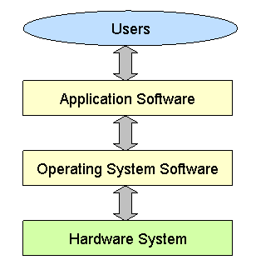

1. **Explain the following terms when considering CPUs**

**multithread:** The act of running multiple parts of one program/process at the same time

**multitask:** The act of running several applications simultaneously.

**multiprocessor:** The ability to support more than one CPU

**multicore:** A single computing component comprised of two or more [CPUs](https://www.computerhope.com/jargon/c/cpu.htm)

1. **What is the function of device drivers?**

Communicate the operative system with the hardware components

1. **What was the main reason users were upset with the Windows 8 operating system interface?**

Its metro design

1. **What tasks (at least 2) can be carried out on the Windows Disk Management tool?**

* Creates partitions
* Initializes disk

1. **What tasks (at least 2) can be carried out in the Windows Task Manager tool?**

* End a process
* Set priority levels

1. **What are the 2 types of hypervisor? How are they different?**

* Type 1 (native)
* Type 2 (hosted)

A type 1 hypervisor runs directly on the hardware whereas a type 2 hypervisor runs on the operative system

1. **What are the advantages (at least 2) of using PC virtualization?**

* It allows multiple operating systems to run on a single PC simultaneously
* It can provide cost savings

1. **Explain the term “roll back the driver” and when would you carry it out?**

Change the currently installed driver to the previously installed driver.

 If a driver update does not work properly

1. **What security measures (at least 2) should be part of a preventative maintenance plan?**

* Install and perform scheduled antivirus scans
* Update regularly

1. **What could cause (at least 2 causes) an operating system to “lock up”?**

* An update has corrupted the operating system.
* The power supply is failing.

1. **What do the following acronyms stand for?**

**CLI:** Command Line Interface

**GUI:** Graphic User Interface